Publisher | Editors

HEWI
Marketing + Innovation

HEWI Heinrich Wilke GmbH
PO Box 1260
D-34442 Bad Arolsen
Phone: +49 5691 82-0
presse@hewi.de
www.hewi.com

Clara Brenneker
Phone: +49 5691 82-214
cbrenneker@hewi.de

Nicolo Martin
Phone: +49 5691 82-106
nmartin@hewi.de

Reprint free of charge - copy requested

The ottensenOpen relies on robust solutions in highly frequented sanitary rooms

Where once a multi-storey high bunker marked the entrance to Hamburg's popular trendy district of Ottensen, today stands one of the district's most interesting office buildings: the ottensenOpen. The planners chose robust barrier-free sanitary solutions from HEWI for the highly frequented office building.

Ottensen is one of Hamburg's most popular residential, business and cultural districts. The special charm of the neighborhood in the west of the city is the colorful mix of people of all ages and cultures. In addition, Ottensen is one of the hotspots of Hamburg's gastronomic scene with its numerous bars, cafés and restaurants. And last but not least, the architecture of the district is an attraction in itself. Ottensen captivates with an exciting mix of old buildings and old industrial architecture from the late 19th and early 20th century.

An attractive office building is being constructed on the former bunker site

The northern entrance to Ottensen was once marked by a six-storey high bunker, which was demolished in 2015. Several parcels of land were combined on the former bunker site for the construction of a new office building. The architectural firm Huke-Schubert Berge designed an office building on the newly created site that creates a successful symbiosis of old and new, traditional and modern.
The reddish-brown clinker facade on the street side and the regular arrangement of the windows with a recessed parapet, which is emphasised by a special clinker ornamental element, are reminiscences of the classic industrial architecture in the former industrial district of Ottensen.
OttensenOpen: Based on historical industrial architecture

The ottensenOpen radiates a mixture of calm and tension. The architects combined the building's varied and exciting cubature with its recesses and curves with a regular and calm façade layout. At the same time, the office building blends in extremely harmoniously with the surrounding architecture of Otten, which consists mainly of old buildings. The six-storey building picks up on the existing heights of the neighbouring houses. In order to further improve the visual integration into the existing buildings, the architects created a setback on the fifth floor at the height of the eaves of the adjoining buildings. At the rear of the ottensenOpen, the five-storey structure forms the modern shape of a commercial courtyard. The inner courtyard is accessed through a passageway from Barnerstraße.

State-of-the-art standards also in the area of accessibility

The ottensenOpen office building has an above-ground area of around 12,600 square metres. The building was deliberately designed so that the space can be used very flexibly and different sized units can be formed as required. Thus, use is possible both in the form of individual and team offices as well as in the form of open work areas. The Altonaer Spar- und Bauverein housing association has set up its new office on the ground floor and parts of the first floor.

The technical equipment of the office building meets the latest standards. The building has lifts and barrier-free access. The architects have planned barrier-free WCs on every floor. There are almost 100 parking spaces in the basement, including charging stations for electric vehicles. In addition, the ottensenOpen has sufficient bicycle parking spaces.

Barrier-free solutions in the sanitary areas

The architects selected Range 805 from HEWI for the barrier-free sanitary rooms. The reduced design of Range 805 enables a clear room setting. Right down to the smallest detail, this range shows that good design and intelligent functions form a single unit. The functional area of the dispenser systems made of high-quality polyamide is colour-contrasting.

The folding support handles of the 805 Classic series, made of satin stainless steel, have many advantages: The material is particularly robust and easy to clean. The stable construction offers protection against vandalism and misuse as well as safe use. Especially in public areas, it is important to provide access to public life without barriers for all people, regardless of their physical conditions.

Architect's office Huke-Schubert Berge

The architectural firm Huke-Schubert Berge has been primarily involved in Hamburg's social housing construction for over 30 years. The architects' core competence lies in the development and realisation of urban housing projects that are geared to the living conditions of the residents and at the same time affordable while maintaining high quality standards. Over the past three decades, more than 2,000 apartments have been realised in Hamburg on the basis of Huke-Schubert Berge's plans, often in close cooperation with building cooperatives. In addition, the 25-strong team of the architectural office is also active in the planning of office buildings.

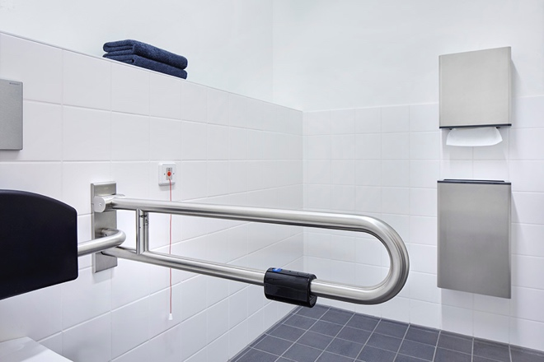

Series 805 in satin stainless steel

Photographer: Andrea Flak

