Publisher | Editors

HEWI
Marketing + Innovation

HEWI Heinrich Wilke GmbH
PO Box 1260
D-34442 Bad Arolsen
Phone: +49 5691 82-0
presse@hewi.de
www.hewi.com

Clara Brenneker
Phone: +49 5691 82-214
cbrenneker@hewi.de

Nicolo Martin
Phone: +49 5691 82-106
nmartin@hewi.de

Reprint free of charge - copy requested

Hygiene in the washroom

In the wake of the Covid 19 pandemic, people are becoming increasingly aware of hygiene in washrooms. Particularly in heavily frequented washrooms in public buildings, hygiene requirements are increasing.To increase this, it is often small changes that make the difference. Above all, touch-free dispenser systems, fittings and antimicrobial door handles help to prevent the spread of viruses and bacteria in washrooms.

New dispenser systems increase hygiene

HEWI therefore offers a wide range of new dispenser systems that meet the highest demands in terms of design and functionality. In addition to dispenser systems such as soap, disinfectant and paper towel dispensers, the range also includes waste bins and hygienic door handles. They can all be perfectly integrated into any room concept thanks to their different surfaces. There is a choice of polyamide, antimicrobial polyamide, powder-coated models in black, grey and white, and stainless steel versions.In each case in manual and electronic form. This Sensoric version enables the user to perform touch-free hand disinfection.

Paper towel dispenser instead of hot air dryer

The use of paper towel dispensers also offers a plus in hygiene in comparison with warm air dryers and jet air dryers. This is the result of an extensive study by scientists at the University of Westminster. According to this, replacement of the devices should lead to a significant reduction in bacteria and virus contamination in sanitary rooms. HEWI offers a suitable selection here that combines design and function.

Non-contact fittings

HEWI SENSORIC fittings maximise hygiene in the washroom. No touching of the fitting is necessary to trigger the water flow - a hand movement is sufficient for this. As a result, the transmission of pathogens is no longer possible. In addition, an automatic hygiene flush, which is also controlled via the app, prevents germs from settling inside the electronic fittings. Flushing can be carried out simultaneously on all installed HEWI SENSORIC fittings. This contributes to increased hygiene and at the same time reduces the cleaning effort. Particularly when water stagnates in the pipes over a longer period of time, hygiene flushing becomes more important in order to maintain the water quality.

Hygienic door handles

However, one of the most frequent transmission paths for bacteria and viruses in the washroom is and remains the door handle. With the 115 model, HEWI has created a clever ergonomic design that can easily be operated with the elbow. This eliminates the need to touch the lever handle with the hand and the washroom can be entered and left hygienically. HEWI active+ lever handles offer additional protection. Due to the antimicrobial effect of HEWI active+ products, the number of germs on the product surface between cleaning and disinfection cycles is significantly reduced. Thus within 24 hours a continuous reduction of unwanted germs on the surface of the products takes place, so that 99.9% of germs are reduced within this period.
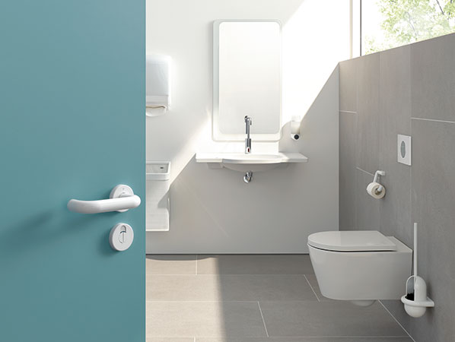
HEWI active+ lever handles offer extra hygiene at the door

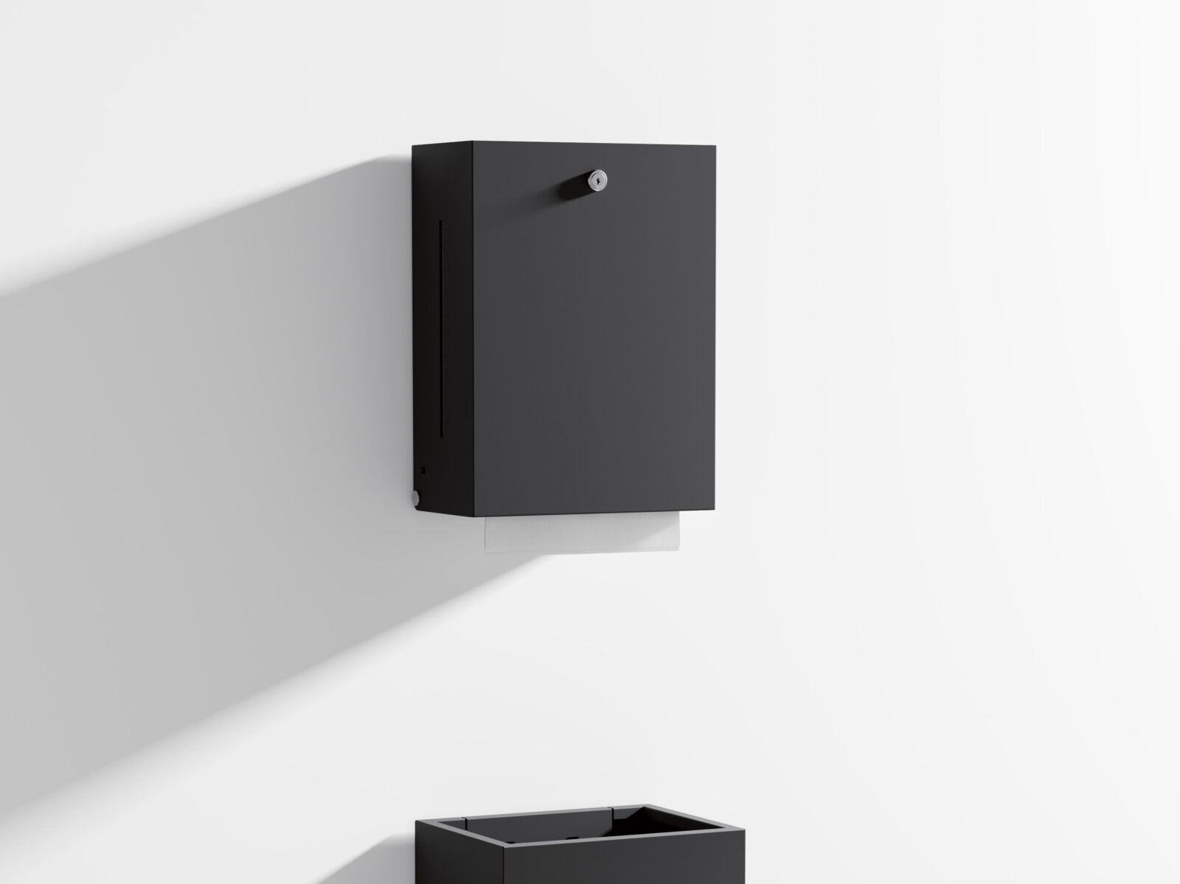
Study shows: Paper towel dispensers are more hygienic than hand dryer fans

